苏州大学实验报告
院、系 | 计算机学院 |  | 年级专业 |  | 22软件工程 |  | 姓名 |  | 学号
课程名称 |  | 程序设计课程实践 |  |  |  |  |  |  | 成绩
指导教师 |  | 程宝雷 |  | 同组实验者 |  | 无 |  | 实验日期 | 2023-3-28

实 验 名 称 | 实验四 方法

- 实验目的
1、理解方法的作用及其创建过程；
2、能够结合具体问题，灵活设计方法。
- 实验内容
1、编程实现文档“上机题4.pdf”中的所有题目。项目名命名为: "EX04_"+学号，每个程序一个类，按题目次序排列。
2、（附加题）编写程序，要求用户输入1至10间的行数（例如7），输出如下的杨辉三角。
1
1 1
1 2 1
1 3 3 1
1 4 6 4 1
1 5 10 10 5 1
1 6 15 20 15 6 1
要求编写三个方法，第一个不使用数组，第二个使用二维数组，第三个使用一维数组。

实验报告命名为学号+姓名+“_实验四.doc"。

- 程序和执行结果（执行结果用截图）
1.
这题比较简单，没什么可说明的。
程序：
import java.util.Scanner;

public class Exercise1 {
/**
* Return the reversal of an integer, i.e., reverse(456) returns 654.
*
* @param number
* @return
*/
public static int reverse(int number) {
int reverse = 0;
while (number != 0) {
reverse = reverse * 10 + number % 10;
number /= 10;
}
return reverse;
}

/**
* Return true if number is a palindrome.
*
* @param number
* @return
*/
public static boolean isPalindrome(int number) {
return number == reverse(number);
}

public static void main(String[] args) {
// Get user input
System.out.print("Enter an integer: ");
Scanner sc = new Scanner(System.in);
int number = sc.nextInt();
sc.close();

// Print result
System.out.println(number + " is " + (isPalindrome(number) ? "" : "not ") + "a palindrome.");
}
}
执行结果：
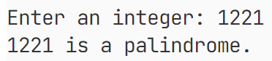
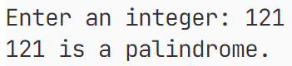
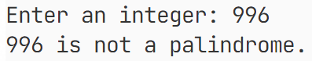

2.
本题只是按题意编写了对应的两个方法，都很简单，没什么可说的。
程序：
public class Exercise2 {
/**
* Calculate m(i) = 1 + 2/3 + 3/4 + ... + i/(i+1)
*
* @param i
* @return
*/
private static double m1(int i) {
double sum = 0;
for (int j = 1; j <= i; j++) {
sum += j / (j + 1.0);
}
return sum;
}

/**
* Calculate m(i) = 4(1 - 1/3 + 1/5 - 1/7 + ... + (-1)^(i+1)/(2i-1))
*
* @param i
* @return
*/
private static double m2(int i) {
double sum = 0;
for (int j = 1; j <= i; j++) {
sum += Math.pow(-1, j + 1) / (2 * j - 1);
}
return 4 * sum;
}

public static void main(String[] args) {
// Print m1
System.out.println("i\tm(i)");
System.out.println("--------------------");
for (int i = 1; i <= 20; i++) {
System.out.printf("%d\t%.4f", i, m1(i));
System.out.println();
}

System.out.println();

// Print m2
System.out.println("i\tm(i)");
System.out.println("--------------------");
for (int i = 1; i <= 901; i += 100) {
System.out.printf("%d\t%.4f", i, m2(i));
System.out.println();
}
}
}
执行结果：
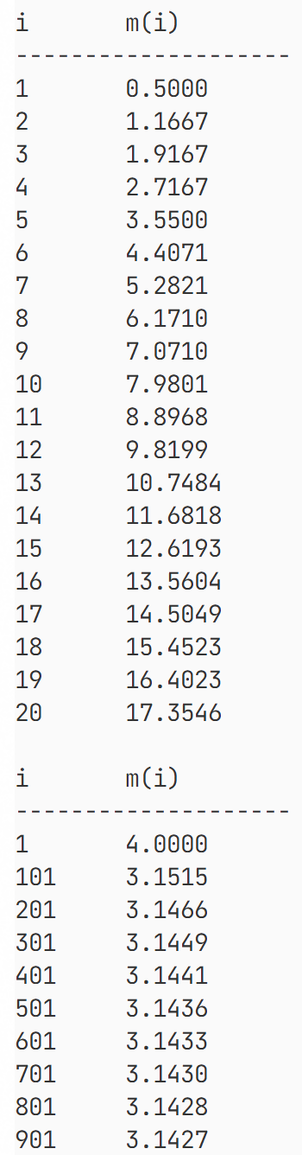

3.
这里按题意定义了几个判断数字类型的函数，都比较简单。唯一需要注意的是对于浮点数比较，使用差值小于1e-6判断是否相等。
程序：
import java.util.Scanner;

public class Exercise3 {
/**
* Judge whether a number is prime.
*
* @param number
* @return
*/
private static boolean isPrime(int number) {
if (number < 2) {
return false;
}
for (int i = 2; i <= Math.sqrt(number); i++) {
if (number % i == 0) {
return false;
}
}
return true;
}

/**
* Reverse a number.
*
* @param number
* @return
*/
private static int reverse(int number) {
int result = 0;
while (number != 0) {
result = result * 10 + number % 10;
number /= 10;
}
return result;
}

/**
* Judge whether a number is a palindrome.
*
* @param number
* @return
*/
private static boolean isPalindrome(int number) {
return number == reverse(number);
}

/**
* Judge whether a number is a palindromic prime (a prime number that is also a
* palindrome).
*
* @param number
* @return
*/

private static boolean isPalindromicPrime(int number) {
return isPrime(number) && isPalindrome(number);
}

/**
* Judge whether a number is an inverse prime (a prime number that is the
* reversal of another prime number, and is not a palindromic prime).
*
* @param number
* @return
*/
private static boolean isInversePrime(int number) {
return !isPalindromicPrime(number) && isPrime(reverse(number));
}

/**
* Judge whether a number is a Mersenne prime (a prime number that is one less
* than a power of 2).
*
* @param number
* @return
*/
private static boolean isMersennePrime(int number) {
return isPrime(number) && Math.log(number + 1) / Math.log(2) % 1 < 1e-6;
}

public static void main(String[] args) {
// Print palindromes
Scanner sc = new Scanner(System.in);
System.out.print("Enter the number of palindromes to display: ");
for (int i = 0, amount = sc.nextInt(), count = 0; count < amount; i++) {
if (isPalindrome(i)) {
System.out.printf("%8d", i);
count++;
if (count % 10 == 0) {
System.out.println();
}
}
}

System.out.println();
System.out.println();

// Print inverse primes
System.out.print("Enter the number of inverse primes to display: ");
for (int i = 0, amount = sc.nextInt(), count = 0; count < amount; i++) {
if (isInversePrime(i)) {
System.out.printf("%8d", i);
count++;
if (count % 10 == 0) {
System.out.println();
}
}
}
sc.close();

System.out.println();
System.out.println();

// Print Mersenne primes that are less or equal to 2^31 - 1
System.out.println("Mersenne primes that are less or equal to 2^31 - 1:");
for (int i = 0, count = 0; i <= 31; i++) {
int number = (int) Math.pow(2, i) - 1;
if (isMersennePrime(number)) {
System.out.printf("%8d", number);
count++;
if (count % 10 == 0) {
System.out.println();
}
}
}
}
}
执行结果：
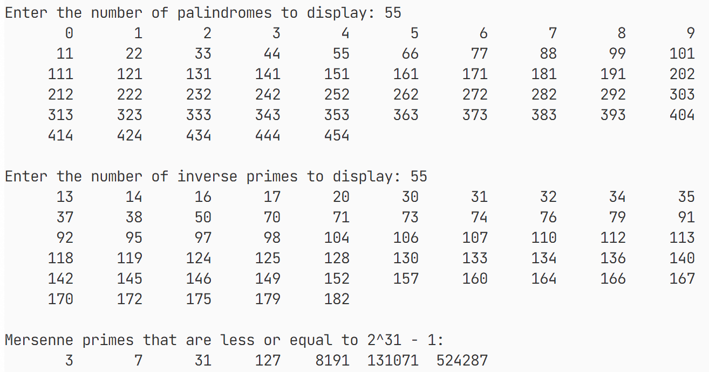

4.
这里定义了一个枚举`State`，表示第一次掷骰子之后的状态：赢、输或继续。然后定义了`rollTwoDice`，它掷两个骰子并计算它们的和；定义了`checkWin`函数，判断第一次掷骰子之后的状态。在主函数中，先掷第一次骰子，调用checkWin判断输赢，如需要继续，则按题意继续游戏判断输赢。
程序：
import java.util.Random;

public class Exercise4 {
private enum State {
CONTINUE, WON, LOST
}

private static final Random rand = new Random();

/**
* Roll the dice (returns a random number between 1 and 6).
*
* @return
*/
private static int roll() {
return rand.nextInt(6) + 1;
}

/**
* Roll two dice and return the sum.
*
* @return
*/
private static int rollTwoDice() {
return roll() + roll();
}

/**
* Check whether the player wins, loses or continues.
*
* @param sum
* @return
*/
private static State checkWin(int sum) {
switch (sum) {
case 7:
case 11:
return State.WON;
case 2:
case 3:
case 12:
return State.LOST;
default:
return State.CONTINUE;
}
}

public static void main(String[] args) {
// Play the game
int point = rollTwoDice();
System.out.println("You rolled " + point);
switch (checkWin(point)) {
case WON:
System.out.println("You win!");
break;
case LOST:
System.out.println("You lose!");
break;
case CONTINUE:
System.out.println("Roll again!");
while (true) {
int sum = rollTwoDice();
System.out.println("You rolled " + sum);

if (sum == point) {
System.out.println("You win!");
break;
} else if (sum == 7) {
System.out.println("You lose!");
break;
} else {
System.out.println("Roll again!");
}
}
break;
}
}
}
执行结果：
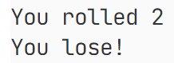
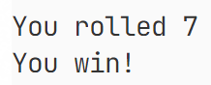
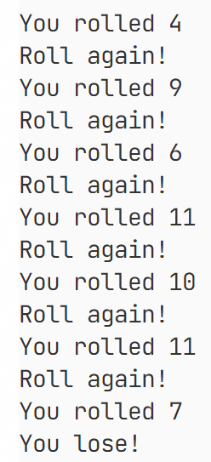
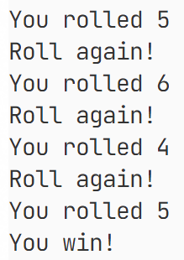

5.
这里首先创建了一个类Point，重写了`toString`方法，其主要目的是为了简化之后输出代码的编写。这里要求的几个函数均采用向量叉积原理编写，总体比较简单。
程序：
import java.util.Scanner;

public class Exercise5 {
private static class Point {
private double x;
private double y;

public Point(double x, double y) {
this.x = x;
this.y = y;
}

@Override
public String toString() {
return "(" + x + ", " + y + ")";
}

public double getX() {
return x;
}

public double getY() {
return y;
}
}

/**
* Judge whether point(x2, y2) is left of the line determined by point(x0, y0)
* and point(x1, y1).
*
* @param x0
* @param y0
* @param x1
* @param y1
* @param x2
* @param y2
* @return
*/
private static boolean leftOfTheLine(double x0, double y0, double x1, double y1, double x2, double y2) {
return (x1 - x0) * (y2 - y0) - (x2 - x0) * (y1 - y0) > 0;
}

/**
* Judge whether point(x2, y2) is on the line determined by point(x0, y0) and
* point(x1, y1).
*
* @param x0
* @param y0
* @param x1
* @param y1
* @param x2
* @param y2
* @return
*/
private static boolean onTheSameLine(double x0, double y0, double x1, double y1, double x2, double y2) {
return (x1 - x0) * (y2 - y0) - (x2 - x0) * (y1 - y0) == 0;
}

/**
* Judge whether point(x2, y2) is on the line segment determined by point(x0,
* y0) and point(x1, y1).
*
* @param x0
* @param y0
* @param x1
* @param y1
* @param x2
* @param y2
* @return
*/
private static boolean onTheLineSegment(double x0, double y0, double x1, double y1, double x2, double y2) {
return onTheSameLine(x0, y0, x1, y1, x2, y2) && (x2 >= x0 && x2 <= x1 || x2 >= x1 && x2 <= x0)
&& (y2 >= y0 && y2 <= y1 || y2 >= y1 && y2 <= y0);
}

public static void main(String[] args) {
// Get user input
Scanner sc = new Scanner(System.in);
System.out.print("Enter x and y for point p0 (separated by a space): ");
Point p0 = new Point(sc.nextDouble(), sc.nextDouble());
System.out.print("Enter x and y for point p1 (separated by a space): ");
Point p1 = new Point(sc.nextDouble(), sc.nextDouble());
System.out.print("Enter x and y for point p2 (separated by a space): ");
Point p2 = new Point(sc.nextDouble(), sc.nextDouble());
sc.close();

// Print result
System.out.println(p2 + " is " +
(leftOfTheLine(p0.getX(), p0.getY(), p1.getX(), p1.getY(), p2.getX(), p2.getY())
? "left of the line from " + p0 + " to " + p1
: onTheLineSegment(p0.getX(), p0.getY(), p1.getX(), p1.getY(), p2.getX(), p2.getY())
? "on the same line from " + p0 + " to " + p1
: "right of the line from " + p0 + " to " + p1));
}
}
执行结果：
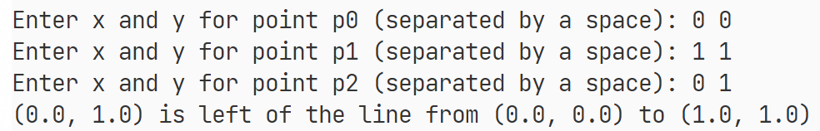
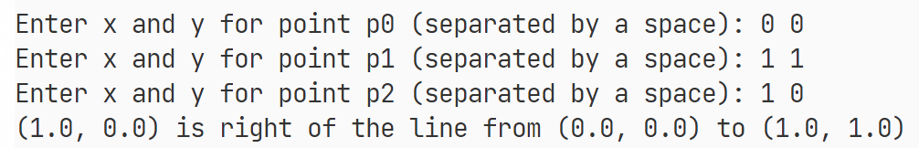
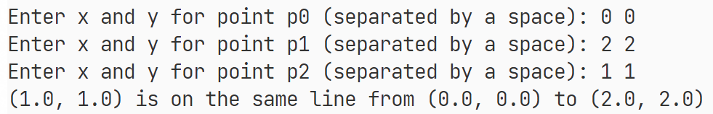

附加题（选做）
这里使用了三种方式打印杨辉三角形（帕斯卡三角形）。第一种方式根据杨辉三角形映射到二项式系数的原理，不使用数组打印杨辉三角形；第二种方式使用一个二维数组，原样地按照最直观的方式计算杨辉三角形存储在数组中，然后打印；第三种方式实际上只是简单地将第二种方式的二维数组打平成一维数组，然后打印，原理相似。
程序：
import java.util.Scanner;

public class Additional1 {
/**
* Calculate the binomial coefficient.
*
* @param n
* @param k
* @return
*/
private static int binomialCoefficient(int n, int k) {
if (k == 0 || k == n) {
return 1;
} else {
return binomialCoefficient(n - 1, k - 1) + binomialCoefficient(n - 1, k);
}
}

/**
* Print Pascal's triangle (not use array).
*
* @param n
*/
private static void printPascalTriangle1(int n) {
for (int i = 0; i < n; i++) {
for (int j = 0; j < n - i; j++) {
System.out.print(" ");
}
for (int j = 0; j <= i; j++) {
System.out.printf("%4d", binomialCoefficient(i, j));
}
System.out.println();
}
}

/**
* Print Pascal's triangle (use a 2d array).
*
* @param n
*/
private static void printPascalTriangle2(int n) {
int[][] pascalTriangle = new int[n][n];
for (int i = 0; i < n; i++) {
for (int j = 0; j <= i; j++) {
if (j == 0 || j == i) {
pascalTriangle[i][j] = 1;
} else {
pascalTriangle[i][j] = pascalTriangle[i - 1][j - 1] + pascalTriangle[i - 1][j];
}
}
}

for (int i = 0; i < n; i++) {
for (int j = 0; j < n - i; j++) {
System.out.print(" ");
}
for (int j = 0; j <= i; j++) {
System.out.printf("%4d", pascalTriangle[i][j]);
}
System.out.println();
}
}

/**
* Print Pascal's triangle (use a 1d array).
*
* @param n
*/
private static void printPascalTriangle3(int n) {
int[] pascalTriangle = new int[n * (n + 1) / 2];
int index = 0;

for (int i = 0; i < n; i++) {
for (int j = i; j >= 0; j--) {
if (j == 0 || j == i) {
pascalTriangle[index + j] = 1;
} else {
pascalTriangle[index + j] = pascalTriangle[index - i + j - 1] + pascalTriangle[index - i + j];
}
}
index += i + 1;
}

index = 0;
for (int i = 0; i < n; i++) {
for (int j = 0; j < n - i; j++) {
System.out.print(" ");
}
for (int j = 0; j <= i; j++) {
System.out.printf("%4d", pascalTriangle[index + j]);
}
System.out.println();
index += i + 1;
}
}

public static void main(String[] args) {
// Get user input
System.out.print("Enter n: ");
Scanner sc = new Scanner(System.in);
int n = sc.nextInt();
sc.close();

// Print Pascal's triangle
System.out.println("Pascal's triangle (not use array):");
printPascalTriangle1(n);

System.out.println();

System.out.println("Pascal's triangle (use a 2d array):");
printPascalTriangle2(n);

System.out.println();

System.out.println("Pascal's triangle (use a 1d array):");
printPascalTriangle3(n);
}
}
执行结果：
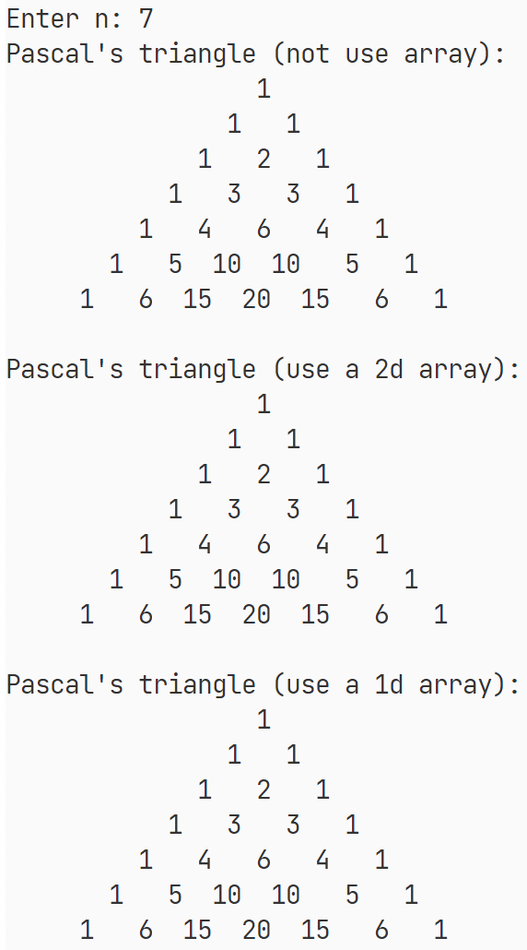

- 实验总结
在本次实验中，学习并通过练习题实践了Java中方法的创建与使用。

